**JavaScript Exercise:**

1. Download the start files from MyCourses (includes recipes.html, recipes.css, recipes.json).
2. In the same folder, create a file called solution.js.
3. In solution.js, make recipes.html look like:

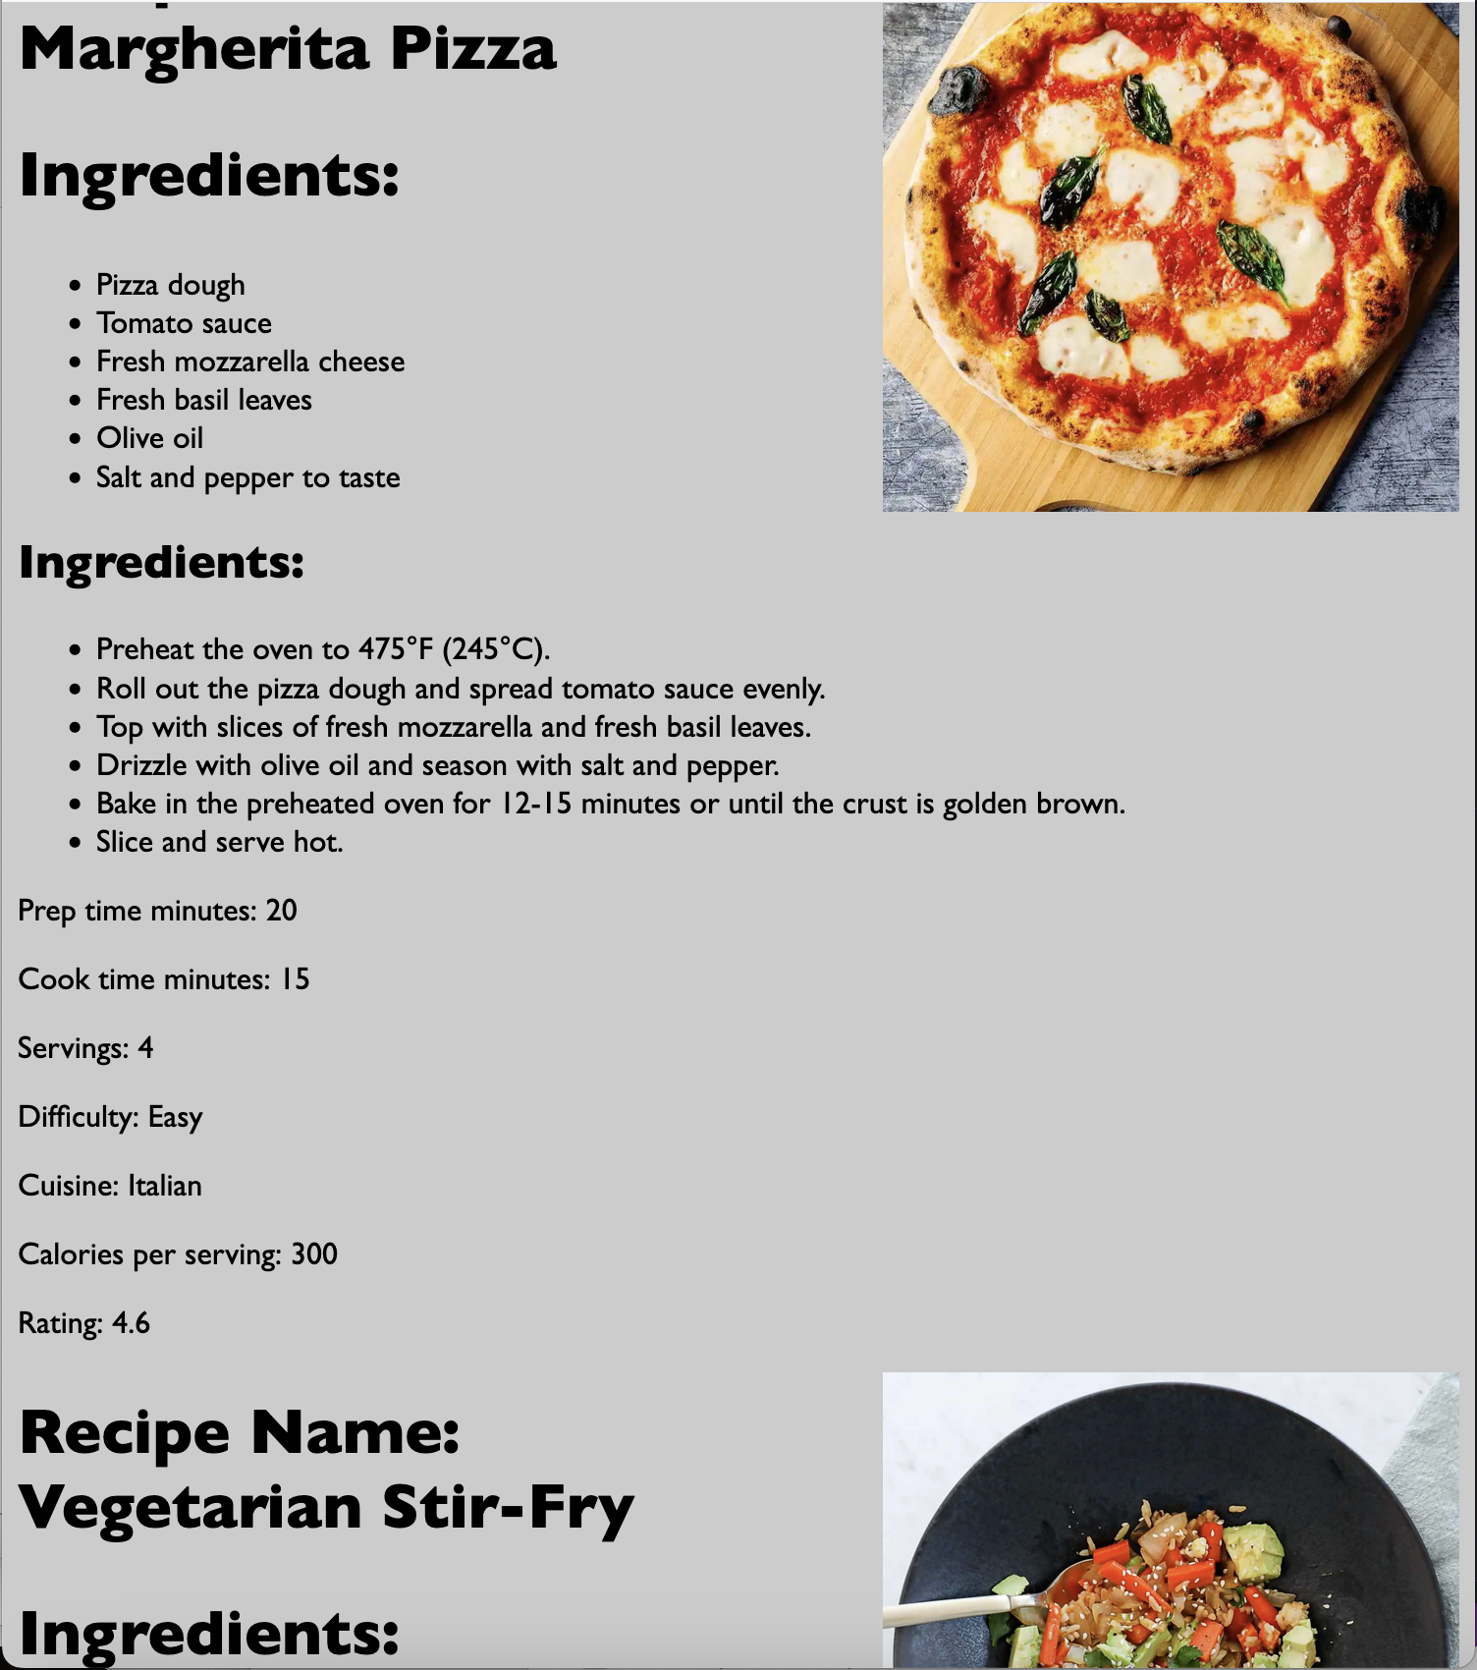

**Rubric**:

|  |  |
| --- | --- |
|  |  |
| JSON const created correctly | 10 |
| Template created for each ingredient | 10 |
| Template created for each instruction | 10 |
| Template created for each recipe | 35 |
| Correctly uses CSS and semantic HTML tags to match sample output | 10 |
| Uses .map appropriately | 10 |
| Uses .insertAdjacentHTML appropriately | 10 |
| Code structure + syntax + naming conventions | 5 |
|  | 100 |